Student ID: 103607336

Name: Rishabh Nigam

# Setup Screenshot

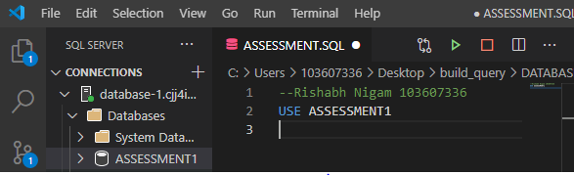

# Task 2 Screenshot

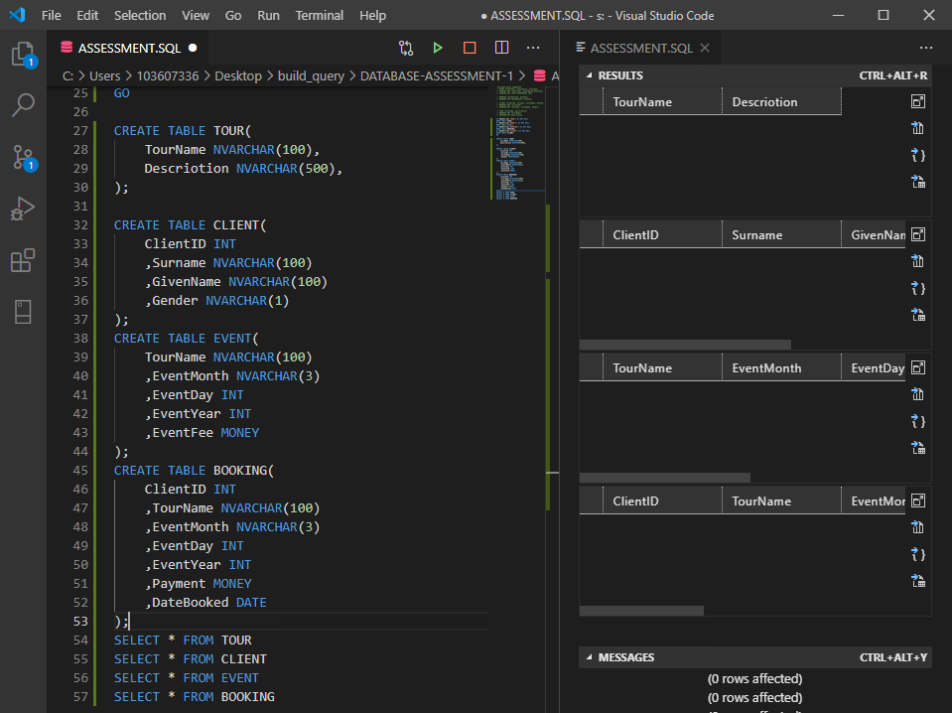

# Task 3 Screenshot

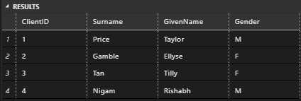

# Task 4 Screenshot

# Task 5 Screenshot

# Task 6 Screenshot